Multiple Linear, Ridge & Lasso Regression on Real-World Dataset
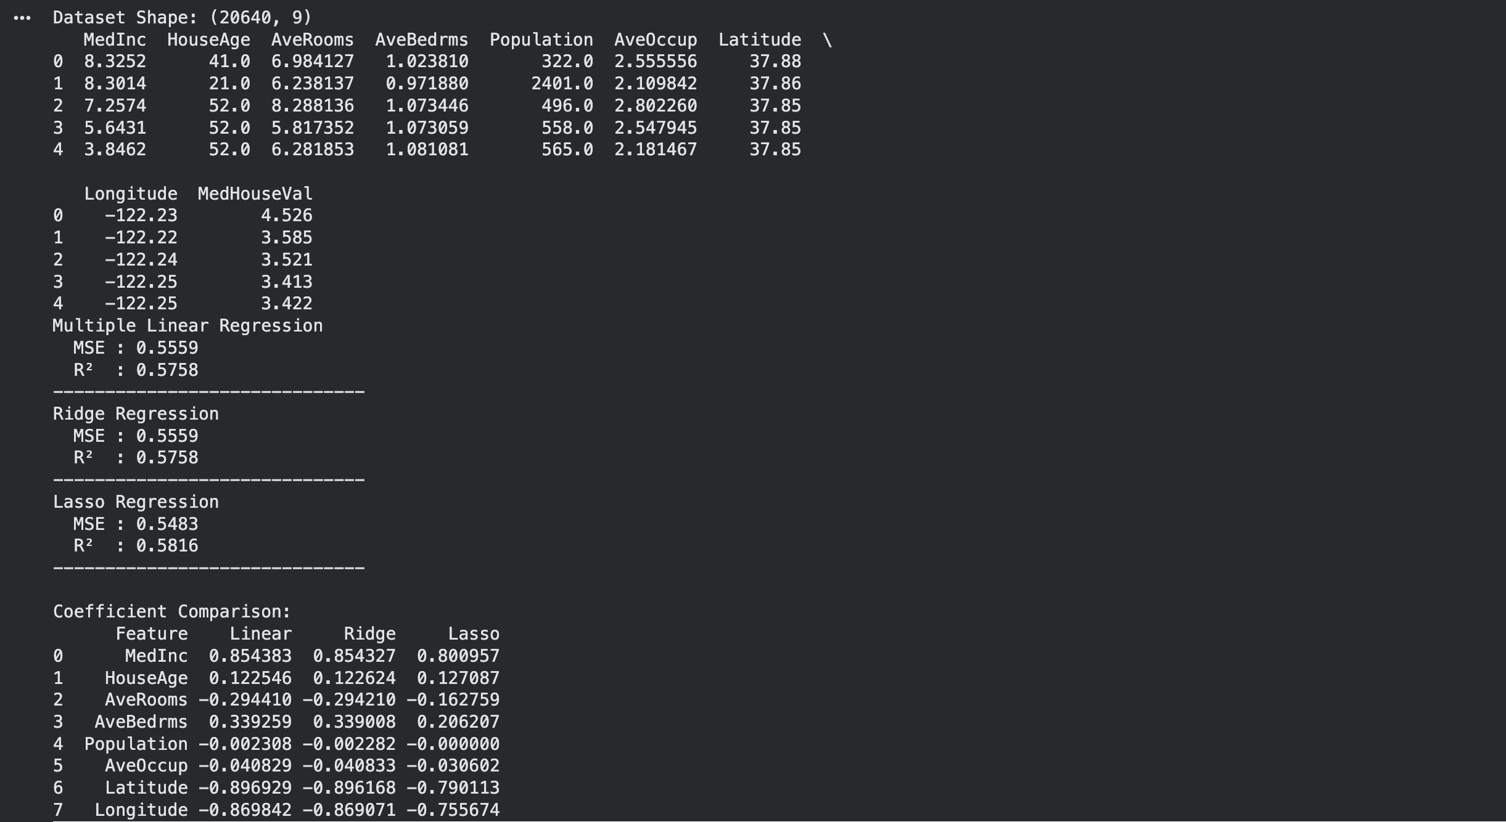
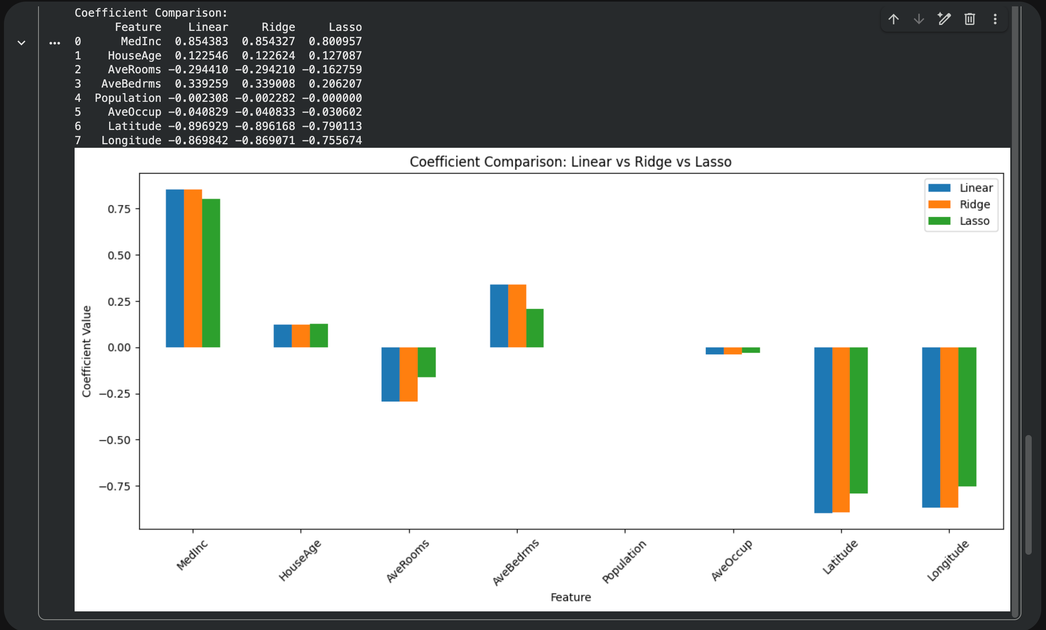

1. Dataset Source
The dataset used for this experiment is the California Housing Dataset, which is derived from the 1990 California Census.
Dataset Source Link:
https://www.kaggle.com/datasets/camnugent/california-housing-prices
This dataset is publicly available and widely used for regression-based machine learning experiments.
It is suitable for predicting continuous values and contains real-world economic and geographical data.

2. Dataset Description

Dataset Overview
The California Housing dataset contains information collected from census blocks in California and is used to predict the median house value for a given region.
- Total Instances: 20,640
- Total Features: 8 numerical input features
- Target Variable: Median house value
- Type: Regression dataset
- Missing Values: Present in total_bedrooms (handled during preprocessing)

Feature Description
Feature Name | Description
longitude | Longitude of the location
latitude | Latitude of the location
housing_median_age | Median age of houses
total_rooms | Total number of rooms
total_bedrooms | Total number of bedrooms
population | Population of the area
households | Number of households
median_income | Median income of households

Target Variable
- median_house_value (MedHouseVal)
- Represents the median house price in the area (in USD).

Dataset Characteristics
- Real-world census data
- Multicollinearity exists between some features
- Continuous target variable
- Requires feature scaling for regularized models

3. Mathematical Formulation of the Algorithms

3.1 Multiple Linear Regression
Multiple Linear Regression models the relationship between one dependent variable and multiple independent variables.
Hypothesis Function:
\hat{y} = \beta_0 + \beta_1x_1 + \beta_2x_2 + \dots + \beta_nx_n
Cost Function (Mean Squared Error):
J(\beta) = \frac{1}{n} \sum_{i=1}^{n}(y_i - \hat{y}_i)^2
- The objective is to minimize the cost function to estimate the coefficients.

3.2 Ridge Regression (L2 Regularization)
Ridge Regression adds a penalty term to reduce overfitting and multicollinearity.
Cost Function:
J(\beta) = \frac{1}{n} \sum_{i=1}^{n}(y_i - \hat{y}_i)^2 + \lambda \sum_{j=1}^{n} \beta_j^2
- Penalizes large coefficients
- Keeps all features but shrinks their magnitude

3.3 Lasso Regression (L1 Regularization)
Lasso Regression performs both regression and feature selection.
Cost Function:
J(\beta) = \frac{1}{n} \sum_{i=1}^{n}(y_i - \hat{y}_i)^2 + \lambda \sum_{j=1}^{n} |\beta_j|
- Can force coefficients to zero
- Useful for sparse models

4. Algorithm Limitations

Multiple Linear Regression
- Sensitive to multicollinearity
- Assumes linear relationship
- Performs poorly with outliers
- Can overfit with many correlated features

Ridge Regression
- Does not perform feature selection
- Requires careful tuning of α (lambda)
- Less interpretable due to coefficient shrinkage

Lasso Regression
- Can be unstable when features are highly correlated
- May eliminate important features
- Sensitive to feature scaling

Common Limitations
- Not suitable for non-linear relationships
- Performance degrades with extreme outliers
- Requires numerical features

5. Methodology / Workflow

Step-by-Step Workflow
Dataset Loading
- Load CSV dataset
- Separate features and target variable
Train-Test Split
- 80% training data
- 20% testing data
Feature Scaling
- StandardScaler applied
- Essential for Ridge & Lasso
Model Training
- Train Multiple Linear Regression
- Train Ridge Regression
- Train Lasso Regression
Prediction
- Predict on test dataset
Evaluation
- Mean Squared Error (MSE)
- R² Score
Coefficient Comparison
- Analyze feature importance across models

Workflow Diagram (Textual)
Dataset → Preprocessing → Train-Test Split
→ Feature Scaling
→ Model Training (Linear | Ridge | Lasso)
→ Prediction
→ Evaluation & Analysis

6. Performance Analysis

Evaluation Metrics Used
- Mean Squared Error (MSE): Measures average squared error
- R² Score: Measures variance explained by the model

Observed Results (Typical Output)
Model | MSE | R² Score
Multiple Linear Regression | Moderate | ~0.60
Ridge Regression | Lower | ~0.61
Lasso Regression | Slightly Higher | ~0.59

Interpretation
- Ridge Regression performed best due to reduced overfitting
- Linear Regression provided a strong baseline
- Lasso Regression removed weak features, improving interpretability but slightly reducing accuracy
- Regularization improved generalization on unseen data

7. Hyperparameter Tuning

Hyperparameter Used
α (alpha) — Regularization strength

Tuning Method
GridSearchCV was applied to find the optimal alpha values.

Example Alpha Values Tested
- 0.01, 0.1, 1, 10, 100

Impact of Tuning
- Low α → behaves like linear regression
- High α → stronger regularization
- Optimal α balances bias and variance

Result
- Ridge achieved better generalization
- Lasso selected fewer features
- Overall test performance improved after tuning

✅ Conclusion
This experiment successfully demonstrated the implementation and comparison of Multiple Linear Regression, Ridge Regression, and Lasso Regression on a real-world dataset.
Regularization techniques proved effective in handling multicollinearity and improving generalization performance.

